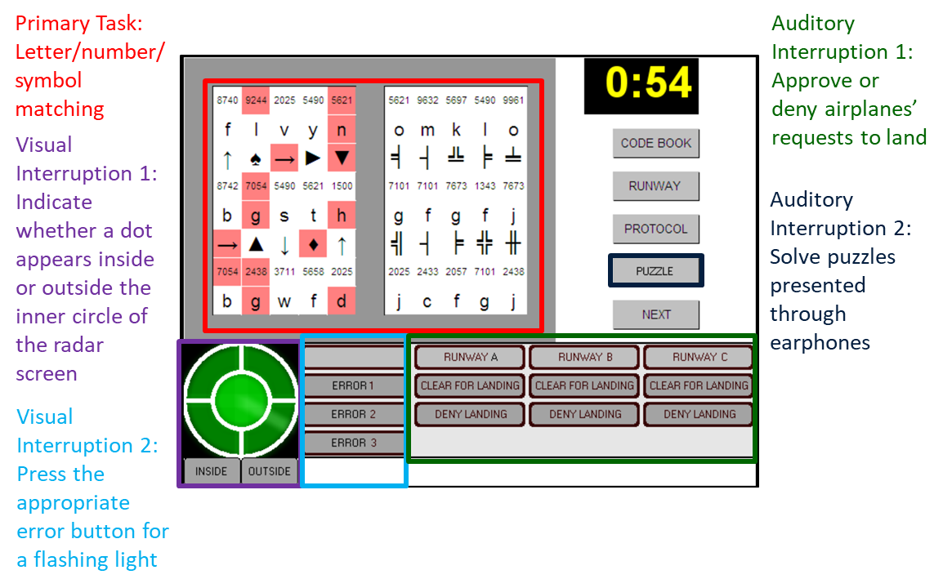
Figure a. A labeled snapshot of the labeled Control Tower interface.

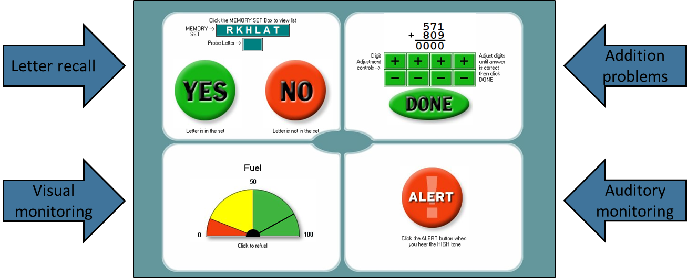
Figure b. A labeled snapshot of the labeled SynWin interface.
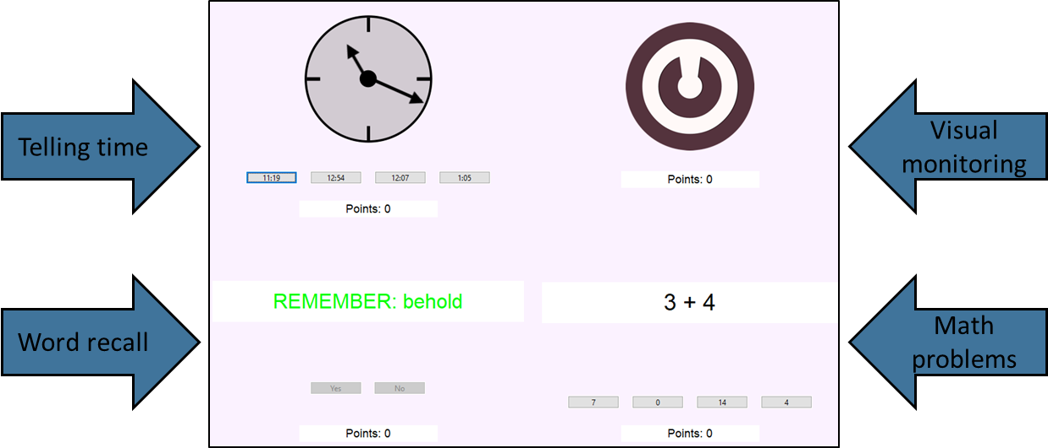
Figure b. A labeled snapshot of the Foster Task interface.

Table 2. Descriptive statistics of measures.
Variable | Mean | SD | min | max | Skewness | Kurtosis
Antisaccade | 0.78 | 0.15 | 0.36 | 0.99 | -0.80 | -0.16
ASVAB Total | 103.06 | 21.79 | 44.00 | 143.00 | -0.44 | -0.26
Control Tower Distract Score | 24.36 | 4.13 | 6.00 | 29.00 | -1.64 | 3.04
Control Tower Primary Score | 96.25 | 36.55 | 17.00 | 186.00 | -0.41 | 0.02
Digit String Comparison | 30.16 | 5.32 | 11.00 | 41.00 | -0.58 | 0.55
Digit Symbol Substitution | 57.76 | 12.49 | 22.00 | 90.00 | 0.31 | 0.57
Flanker Effect | 82.95 | 44.51 | -13.86 | 238.36 | 1.25 | 2.35
Foster Task | 14994.87 | 10020.15 | 0.00 | 47915.00 | 0.81 | 0.52
Letter Sets | 16.60 | 4.53 | 5.00 | 28.00 | -0.24 | -0.28
Letter String Comparison | 20.85 | 3.86 | 11.00 | 37.00 | 0.35 | 1.21
Number Series | 9.30 | 3.32 | 2.00 | 15.00 | -0.33 | -0.78
RAPM | 9.61 | 3.23 | 2.00 | 18.00 | -0.15 | -0.40
SACT | 0.70 | 0.19 | 0.19 | 0.97 | -0.77 | 0.12
Selective Visual Arrays | 1.71 | 1.13 | 0.00 | 4.45 | 0.17 | -0.80
Stroop Effect | 132.52 | 83.20 | -52.65 | 431.09 | 0.80 | 1.16
SynWin | 395.75 | 211.16 | -567.33 | 792.00 | -1.27 | 2.49

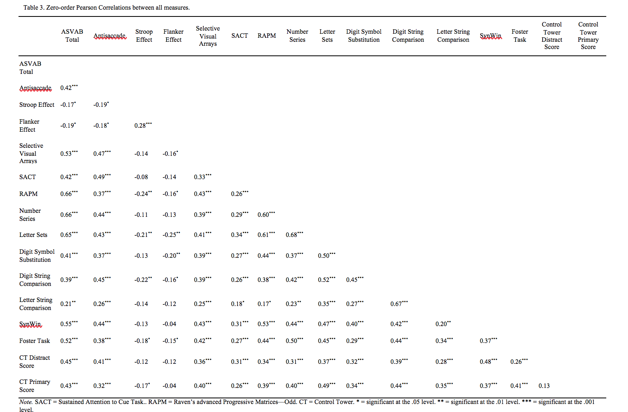

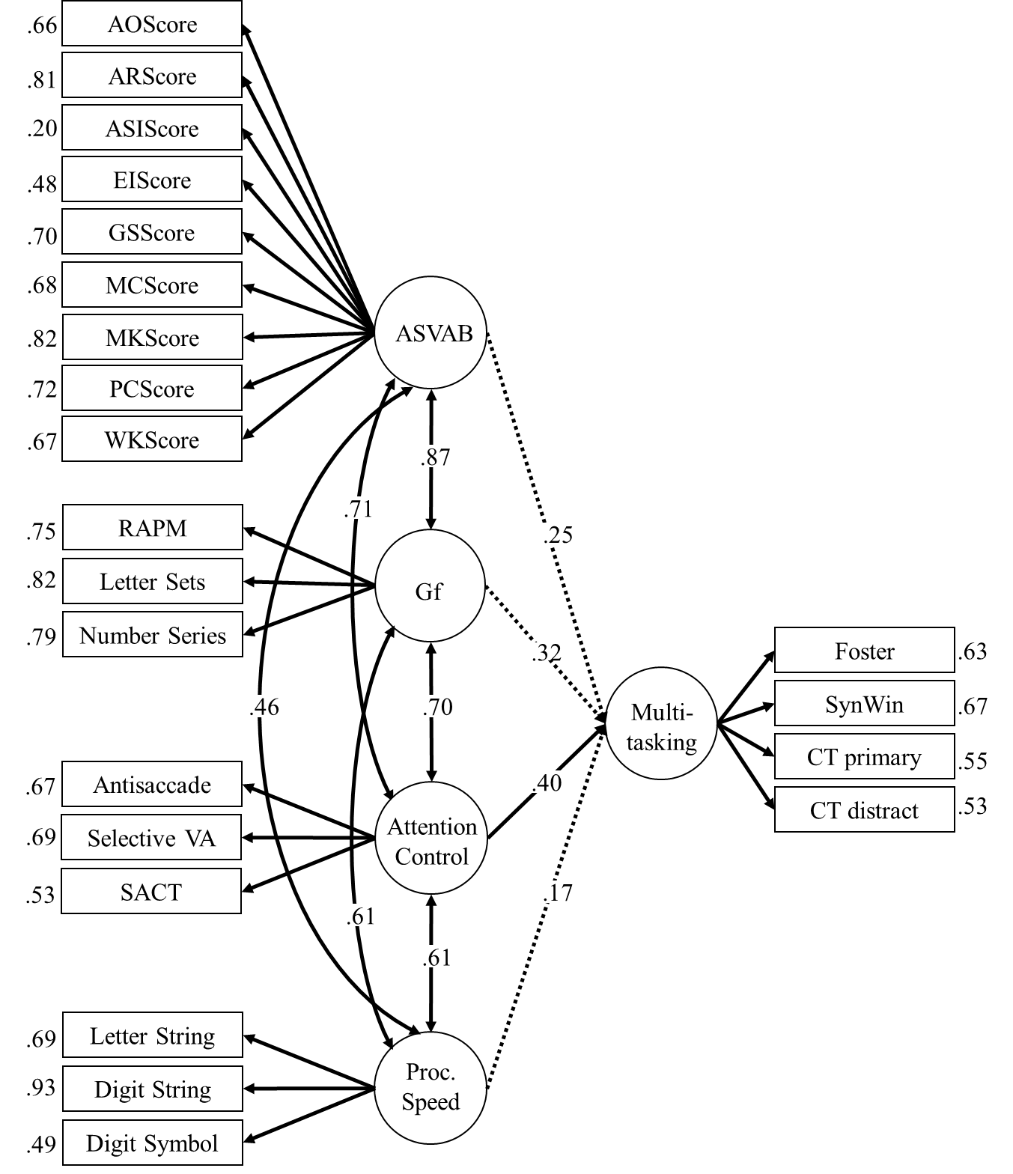

Figure 4. Processing speed (PS) was included as an additional latent variable as a measure of discriminant validity. Although processing speed also significantly predicted multitasking, the attention control path to multitasking remained strong and significant. χ²(199) = 357.557, p < .001, CFI = .904, RMSEA = .068.

